Figen Suchanek

Theoretical and Physical Chemistry

Prof. Foley

4/10/2019

**“How Cool is That”**

### Question 1: In what spectral region does Planck's Blackbody Law peak at 300 K? How does this compare to the peak of the solar spectrum?

Planck radiation has a maximum intensity at a wavelength that depends on the temperature of the body. The surface of the sun (~6000 K) emits large amounts of both infrared and ultraviolet radiation; its emission is peaked in the visible spectrum. This shift due to temperature is called [Wien's displacement law](https://en.wikipedia.org/wiki/Wien%27s_displacement_law) (<https://wwelsh.sdsu.edu/~wwelsh/CLASSES/ASTROBIO/LECTURES/wien_law.pdf>., 2019).

**Wien's shift**

The wavelength of the peak of the blackbody radiation is proportional to 1/T and is called "Wien's shift" or "Wien's displacement law". In other terms, the hotter the body, the shorter the wavelength. The Wien's equation is given below

(<https://wwelsh.sdsu.edu/~wwelsh/CLASSES/ASTROBIO/LECTURES/wien_law.pdf>, 2019):

**λ**max= (b) / (T)

b: Wien's displacement constant (2.8977685 x 10-3- Meter-Kelvin), T: Temperature (Kelvin),  **λ**max : peak energy emission wavelength

Assuming a temperature of 300 K, we can calculate the peak energy emission wavelength as following:

**λ**max= (2.89776829.10-3) / (300) = 9.66.10-6 m = 9.66 Micrometer

The spectral region Planck’s Blackbody Law peaks at 300 K ranges in the visible infrared region.

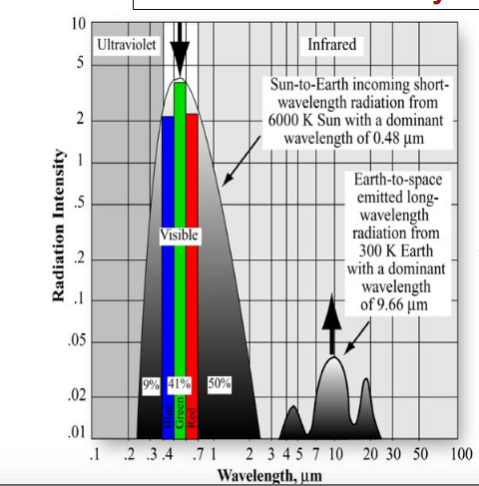

**Figure 1. Wavenumber versus Intensity at 300 K**

**(image credit:** [**https://topex.ucsd.edu/rs/Lec06.pdf**](https://topex.ucsd.edu/rs/Lec06.pdf)**, 2019)**

**Question 2: What properties do you think an ideal cooling material should have in terms of its emissivity/absorptivity in the spectral region that overlaps with the solar spectrum?**

Thermal energy is defined TE (**λ**, T) = P (**λ**, T) .E (**λ)** or

TE (**λ**, T) = P (**λ**, T) . A (**λ)**

P TE (**λ**, T) is Planck’s Blackbody Law, E (**λ)** Emissivity**,**

A (**λ**) Absorptivity. Also, absorptivity/emissivity of an opaque material is complemantary to its reflectance (transmisitty 0-the rooftop opaque):

E (**λ) = 1-** R (**λ)**

If R=0 Emissivity will equal to 1. It means that absorptivity will be 100 percent and the material will act as a blackbody (A **blackbody** will absorb all radiation but fails on reflecting it). If R=1 Emissivity will equal to 0. It means that the light will be 100 percent reflected. So, the more light is reflected the less energy will be absorbed. It will be the ideal case for the cooling materials.

However, “the cooling energy savings for reflective roofs are highest in hot climates. A reflective roof may also lead to a higher heating energy use. Clearly, reflective roofs are not recommended for cold climates where there is no need to cool the buildings” (Akbari, S., 1998).

**Question 3: What properties do you think an ideal cooling material should have in terms of its emissivity/absorptivity in the spectral region that overlaps with the Blackbody spectrum at 300K?**

Please see the pdf. Attachment for question 3

**Question 4: How can you explain the origin of the radiation flowing from the earth's atmosphere to the structure? Why does the sky itself radiate?**

As it can be seen from Table 1, total incoming energy from the earth’s atmosphere to the structure is the combination of short wave radiation from the sun (47 energy unit) and long wave radiation from gases in the atmosphere (98 energy unit).

The sky itself radiates due to the sun’s rays intercepting the atmosphere. The sun radiates the light in a continuous stream of wavelengths. Once the light waves hit the atmosphere and ground, the energy stored in the waves heats up the soil and air, allowing conduction/convection/radiation to occur and move energy around the earth/atmosphere system (<https://climate.ncsu.edu/edu/Radiation>, 2019)

Table 1. At the earth’s surface-Energy absorbed is balanced with the energy released (<https://www.weather.gov/jetstream/energy>, 2019).

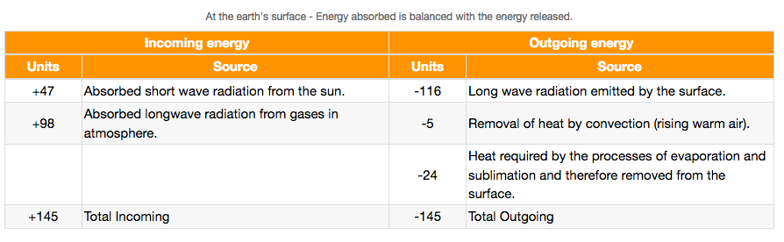

References:

1)<https://wwelsh.sdsu.edu/~wwelsh/CLASSES/ASTROBIO/LECTURES/wien_law.pdf>, 2019

2)[**https://topex.ucsd.edu/rs/Lec06.pdf**](https://topex.ucsd.edu/rs/Lec06.pdf)**, 2019**

**3)** <https://climate.ncsu.edu/edu/Radiation>, 2019

4) <https://www.weather.gov/jetstream/energy>, 2019

5)Akbari, S. and Konopacki, S., The impact of reflectivity and emissivity of roofs on building cooling and heating energy use, Berkeley Lab., Conference Proceedings, 1998 . (https://heatisland.lbl.gov/publications/impact-reflectivity-and-emissivity)